E-Team presents…

FATE/NONSTOP



Version: 0.0.1

A Game Development Project as Requirement for the course EMC131

Alfonso, Favio Maximo G.

Besana, A.L. Schatz A.

Faller, Amiel Ed Angelo A.

Maldonado Zavala, Alvaro



GAME DESIGN DOCUMENT

# Game Name: Fate/Nonstop

## Genre: 2D Side-Scrolling Arcady Platformer

## Game Elements:

* Automatic running through levels filled with obstacles *(for future development)*
* Being chased by a robot *(for future development)*
* Avoiding hazards
* Collecting stars and hidden documents *(for future development)*
* Platforming includes parkour elements *(for future development)*
* Bar on screen that gives more points based on perfect execution *(for future development)*
* Competing for best level time *(for future development)*

## Player:

* Single-player only

# TECHNICAL SPECS

## Technical Form:

* Flat 2D graphics

## View:

* Side-scrolling 2D camera, following the player horizontally and vertically

## Platform:

* PC

## Language:

HTML and Javascript, using Phaser Engine

## Device:

* PC

# GAME PLAY

In *Fate/Nonstop*, formerly *Project Sprint,* players take on the role of a future resistance figure on the run through a modern urban cityscape, relentlessly pursued by a deadly robot assassin sent back in time. The action unfolds as a fast-paced, side-scrolling platformer where the player automatically sprints through dynamically designed levels filled with obstacles that demand split-second timing and perfect execution. Players must master parkour-inspired movements—vaulting over barriers, wall-jumping between narrow gaps, and sliding under hazards—to stay ahead of their pursuer. The chase is intense and constant, with a visible timer and a precision execution bar rewarding players with higher scores for flawless runs. Along the way, players collect glowing stars to boost their score and uncover hidden documents that reveal the larger story behind the AI war. Having three levels, each present a new segment of the city, from towering buildings to precarious rooftops to a military base and ending on a weapons testing laboratory, each offering increasing difficulty and tighter margins for error. Only the most skilled runners will survive the chase and live to fight for humanity’s future.

## Game Play Outline

**Opening the game application**

* + Player launches *Fate/Nonstop*.
  + Splash screen and logo appear.
* Main menu loads with cityscapes background, the main character, view credits, and game title.

**Game options**

* Toggle sound/music volume.
* Toggle windowed/fullscreen mode.
* Keybinding customization. *(for future development)*

**Story synopsis**

* The year is 2025. Unknown to the world, an AI uprising is brewing. One man — a resistance leader in the near future — has become the key figure responsible for humanity’s fight against the machine. A robot assassin is sent to the present day to eliminate him before he can alter the tide of war. Now, he must outrun and outwit his pursuer through the city’s streets, rooftops, and hidden military facilities to survive and safeguard the future.

**Modes**

* **Main Story Mode:** Play through 3 story-driven levels.

**Game elements**

* Automatic sprinting through levels. *(for future development)*
* Chase mechanic (robot follows the player). *(for future development)*
* Parkour-style platforming (wall-jumping, vaulting, sliding). *(for future development)*
* Collecting observation data (stars).
* Discovering hidden areas and collecting hidden documents. *(for future development)*
* Precision execution (perfect flow) bar that rewards skillful movement. *(for future development)*
* Level time and score display. *(for future development)*

**Game levels**

1. **Office Buildings and Rooftops** – Starting level, introduces basic mechanics.
2. **Rooftop Escape** – Faster pace, more hazards and vertical navigation.
3. **Military Base & Weapons Lab** – Complex level design, final showdown.

**Player’s controls**

* Jump: W key
* Slide: S key
* Change direction to left: A key
* Change direction to right: D key
* Sprint: Shift key *(for future development)*
* Wall Jump: Move toward wall and Jump (Spacebar/W/Up) *(for future development)*
* Pause: Escape or P key *(for future development)*

**Player actions**

* Auto-run (changeable directions) *(for future development)*
* Change running directions from left to right side of screen for dynamic gameplay
* Sprint (temporary speed boost, player controlled) *(for future development)*
* Jump
* Wall-jump *(for future development)*
* Vault over objects *(for future development)*
* Slide under objects*(for future development)* or jump over hazards
* Precision execution (perfect flow chaining) *(for future development)*

**Winning**

* Reach the end of the level to collect observation data before the pursuing robot catches the player or time runs out *(for future development)*.

**Losing**

* Player gets caught by the robot. *(for future development)*
* Player runs into a hazard or fails a major obstacle.

**End**

The player’s performance in collecting Observation Data and hidden documents determines the outcome of the final encounter:

* **Incomplete Observation Data:** The player narrowly escapes from the robot. The robot is then dispatched by the military but it only suffers superficial damage. The ending cutscene shows the robot severely damaged but managing to repair itself and resume the hunt, hinting that the threat is far from over. *(for future development)*
* **Complete Observation Data only:** Using the observation data collected, the player and the military deliver significant damage to the robot, temporarily decommissioning it. However, an ending scene reveals that the machine is slowly repairing itself—leaving the future uncertain. *(for future development)*
* **Complete Observation Data + All Hidden Documents:** Using all the data collected, the player and military deal devastating, lethal damage that completely destroys the robot. However, the final cutscene shows transmissions being sent back to the AI network—hinting that more assassins are already being prepared. *(for future development)*

**Why is all this fun?**

* The **chase mechanic** delivers a constant sense of urgency and adrenaline. *(for future development)*
* **Parkour platforming** is fluid and skill-based, rewarding player mastery. *(for future development)*
* **Observation Data and document collection** adds depth and replayability—players will want to optimize routes to get the best ending. *(partially in development)*
* The **execution bar** provides feedback and rewards skilled movement, creating a "flow state" as players string together perfect runs. *(for future development)*
* The game world and story offer **The Terminator/Vector-inspired dystopian atmosphere** that pulls players into a high-stakes narrative. *(for future development)*
* Competing for **best level times** encourages replayability and skill perfection. *(for future development)*

## Key Features

* Fast-paced auto-sprint 2D platforming with parkour-inspired controls. *(for future development)*
* Chase tension: constantly being pursued by a deadly robot. *(for future development)*
* Observation Data and Hidden Documents impact the story’s ending. *(for future development)*
* Precision execution bar rewards skillful play. *(for future development)*
* Timed runs encourage replayability. *(for future development)*
* Branching endings based on collectible performance. *(for future development)*
* Atmospheric, story-rich urban environments (city, rooftops, military base).
* Fluid player movement system that rewards learning and mastery. *(for future development)*

# DESIGN DOCUMENT

## Design Guidelines

* Keep the tension **constant** — the player should always feel "chased." *(for future development)*
* Movement must be **fluid** and **responsive**, allowing high skill expression.
* The art style should support **readability** — players must clearly see obstacles and threats.
* Robot presence should be **felt** at all times (audio cues, screen darkening, distance meter). *(for future development)*
* The collectible system (Observation Data & Documents) must integrate naturally into level flow.
* Levels should reward exploration for advanced players without forcing it upon casual ones. *(for future development)*
* Endings should feel impactful based on player performance. *(for future development)*

## Game Design Definitions

* **Winning:** Player reaches the end of the level before being caught or colliding against a hazard.
* **Losing:** Player is caught by the robot or dies via hazard.
* **Level transitions:** After each level, progress screen shows data collected and player proceeds to the next stage.
* **Gameplay focus:** Tense, fluid chase experience with parkour platforming and a collectible-driven ending system.

## Player Definition

The player controls a **future resistance figure** being hunted through a modern urban landscape. Agile, skilled, and desperate, the player must use parkour and instinct to survive.

### Player Definitions

* **Health:** No health bar; one hit = failure (caught by robot or death by hazard).
* **Weapons:** None; this is a pure escape-focused experience.
* **Actions:** Auto-run, jump, wall-jump, vault, slide, precision execution.

### Player Properties

|  |  |
| --- | --- |
| **Property** | **Feedback** |
| Movement Speed | Automatic run (base speed), Sprint (player activated — burst of higher speed, allows longer jumps and can widen distance from the robot temporarily; limited by stamina/recharge or cooldown). |
| Precision Execution Bar | Fills on perfect parkour and flow of movements; visual/audio feedback. Higher bar multiplies score. |
| Robot Distance Meter | Visual UI element shows robot proximity; screen darkens as robot nears. |
| Robot AI Behavior | Robot auto-chases at a base speed but dynamically accelerates if the player misses flow sequences or makes mistakes during their run and decelerates or “makes mistakes” to keep the chase going. It remains off-screen but briefly appears on-screen if the player makes a mistake, is nearly caught, or is finally caught. |
| Observation Data Collected | Displayed post-level; affects story ending. |
| Hidden Documents Collected | Displayed post-level; affects story ending if fully collected. |

### Player Rewards (power-ups and pick-ups)

* **Observation Data (Stars):** Main collectible — affects robot damage at the end.
* **Hidden Documents:** Unlocks more detailed lore and upgrades ending impact. *(for future development)*
* **Precision Execution Bar Multiplier:** Higher multipliers give better score bonuses and leaderboard placement. *(for future development)*

## User Interface (UI)

*Figure 1: Conceptual Main Menu*

The **Main Menu UI** shows the game’s title and offers options to start the game, view player stats, or access the credits. Settings and exit options are accessible from the bottom-right corner.



*Figure 2: Player Score Statistics (Best Score and Time)*

The **Stats Menu UI** will display the scoreboard containing your best run times with the game. It’s still in development and will be implemented in the future.

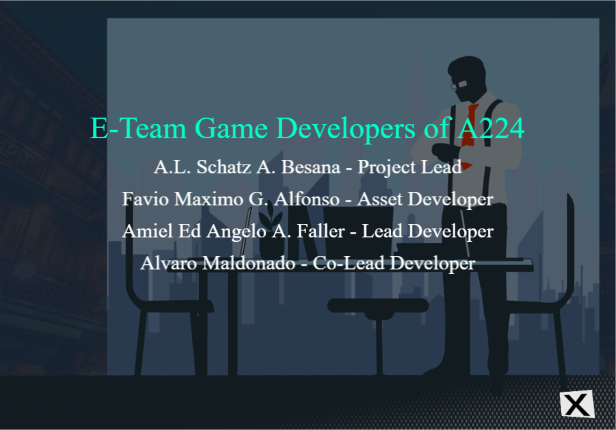

*Figure 3: Credits Menu*

The **Credits Menu** displaying the name of the team and names of the game’s developers, including their respective roles.

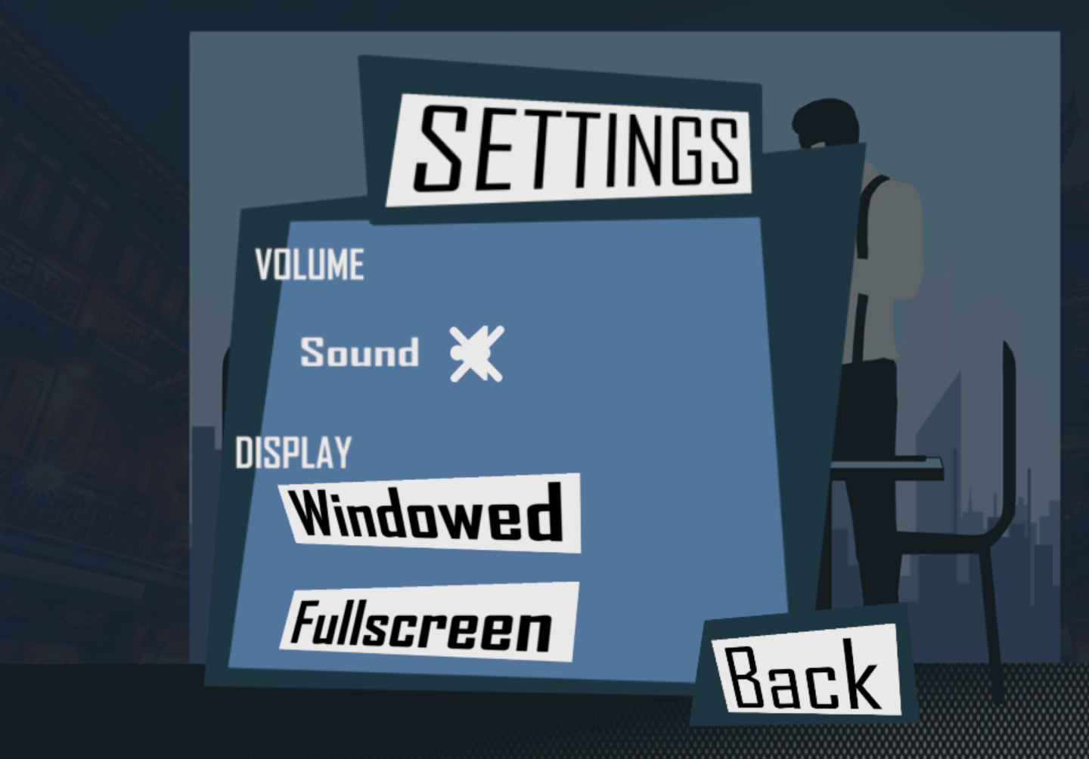

*Figure 4: Settings Window*

The **Settings Window** for both the main menu and the gameplay submenu. It includes buttons that can turn all sounds **ON** or **OFF** (music and sfx), it also includes display buttons that change your view from **WINDOWED** or **FULLSCREEN** mode, and a **BACK** button that brings you back to the previous scene you were in.

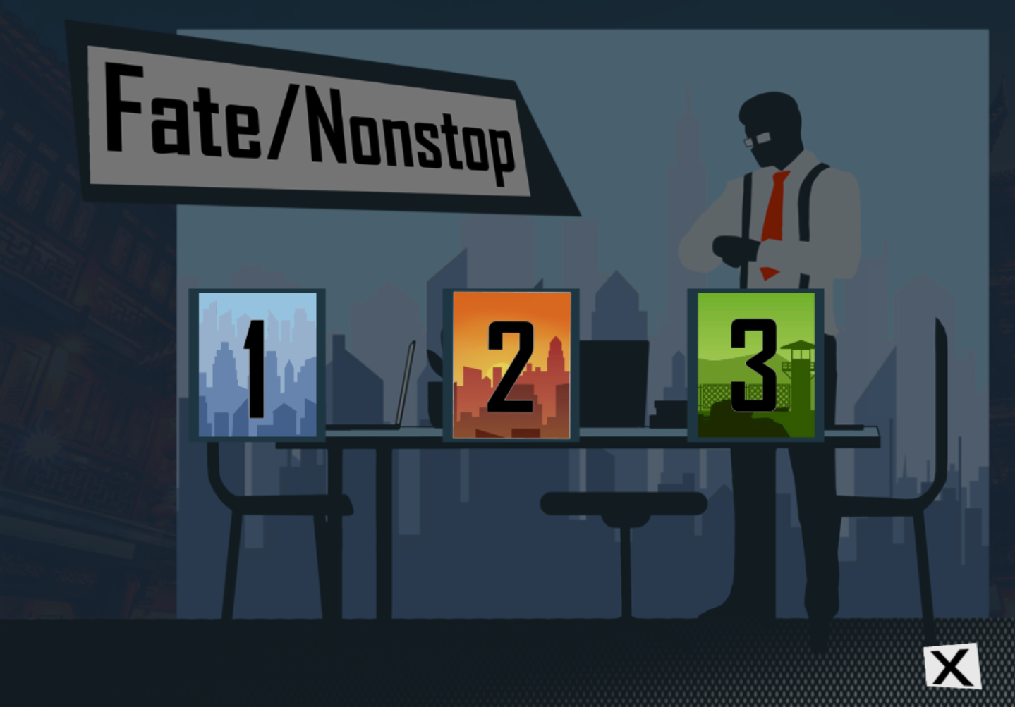

*Figure 5: Settings Window*

The **Level Selector** containing three level buttons, each representing a different level layout. Level one being cityscapes, level two down in suburbs, and level three in a military base.

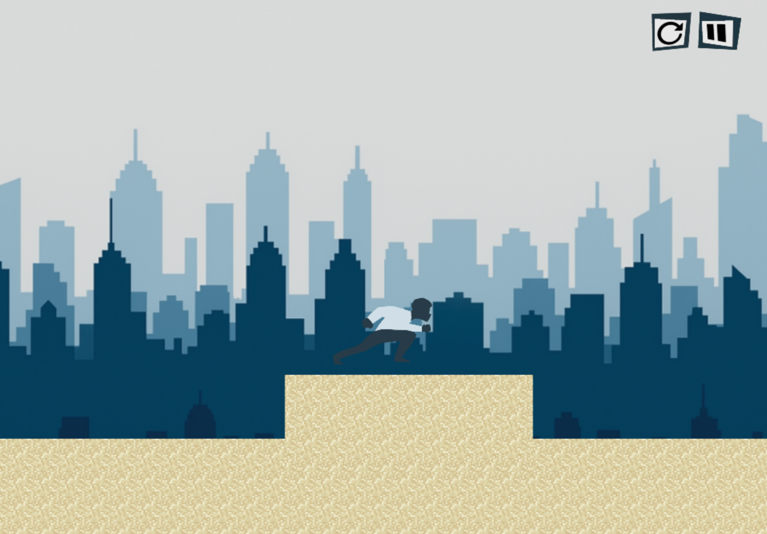

*Figure 6.A: Level One with HUD (heads-up display)*

*Figure 6.B: Level Two with HUD (heads-up display)*

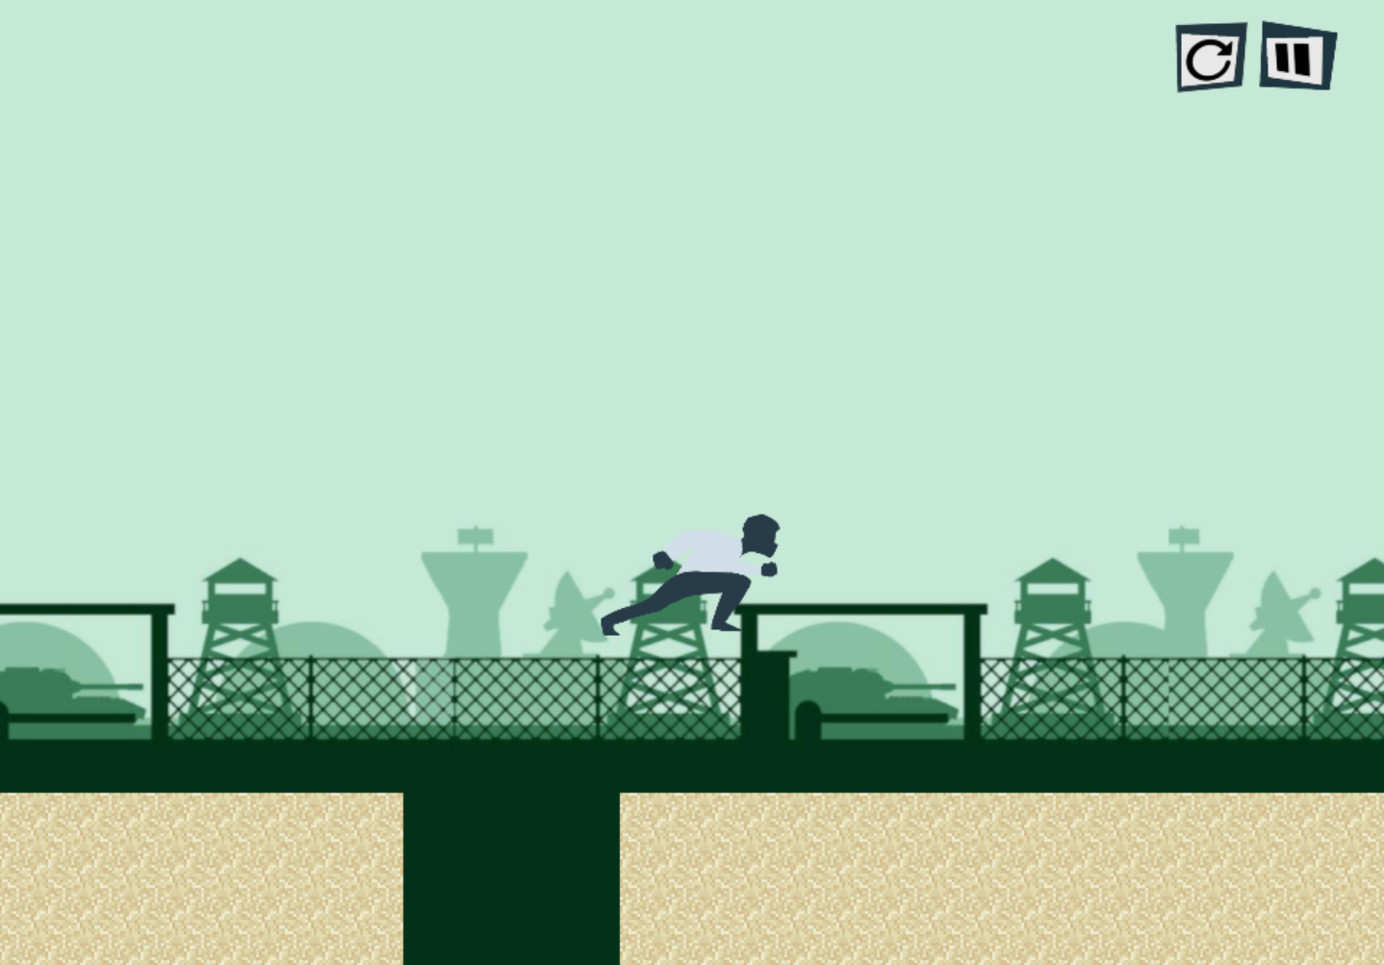

*Figure 6.C: Level One with HUD (heads-up display)*

All three levels of the game, that includes a current level restart button, and a pause button.

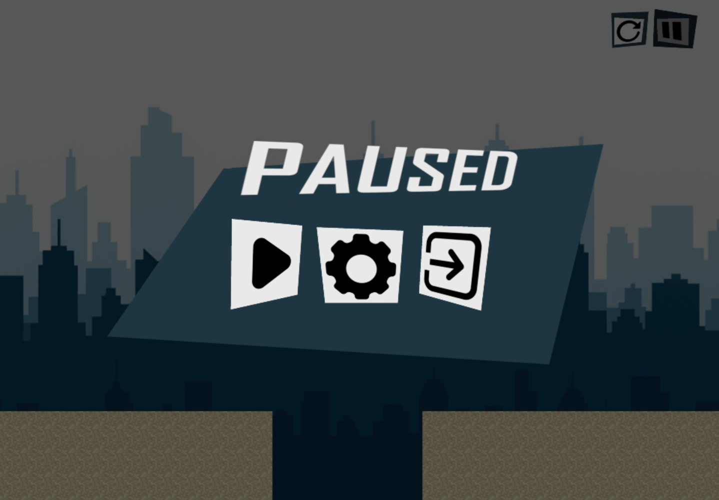

*Figure 7: In-game Pause Menu*

The **In-game Pause Window** that shows three different buttons: A continue button that continues the game, a settings button that takes you to the settings, and an exit button that takes you back to the main menu.

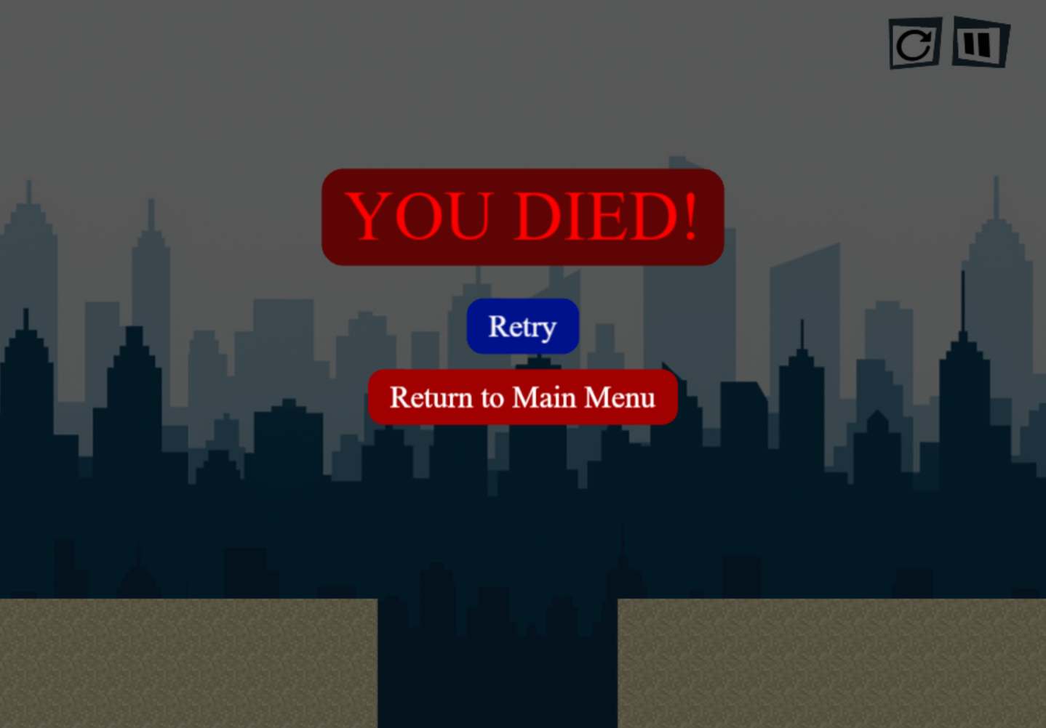

*Figure 8: Lose-Game Screen*

The **Losing Screen** of the game. This is the overlay that appears when you hit the lose condition, showing a retry button and a return to main menu button.

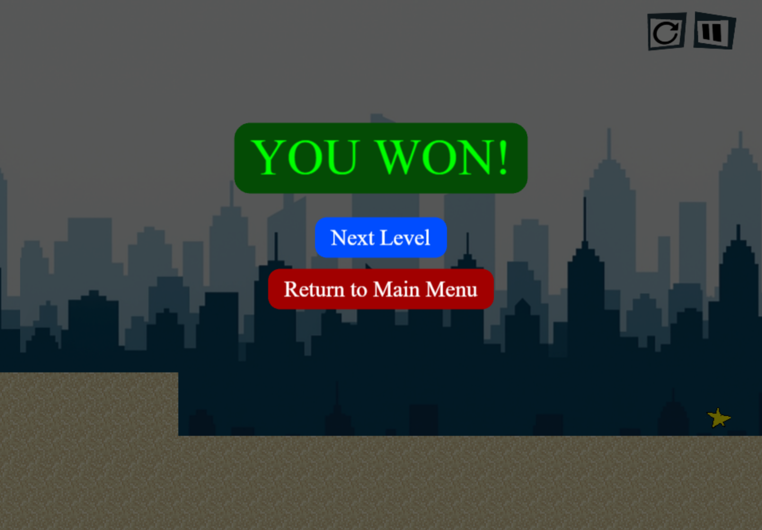

*Figure 9.A: Win-Game Screen w/ Next Level*

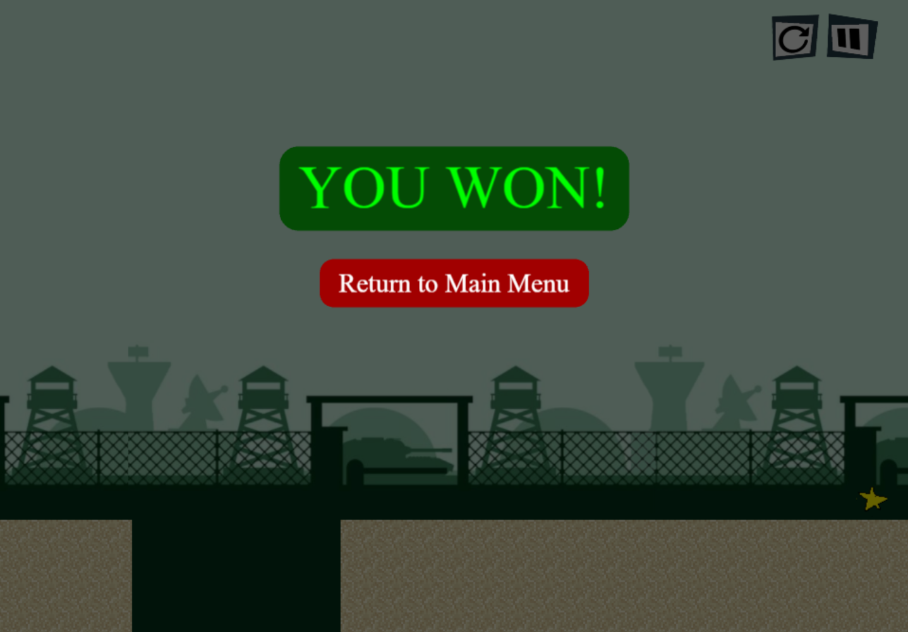

*Figure 9.B: Final level Win-Game Screen*

The **Win-game overlay** that shows up when collecting the observation data (star). It shows text saying you won the level, then two buttons: A **NEXT LEVEL** button that takes you to the next level and/or a **RETURN TO MAIN MENU** button that brings you to the main menu.

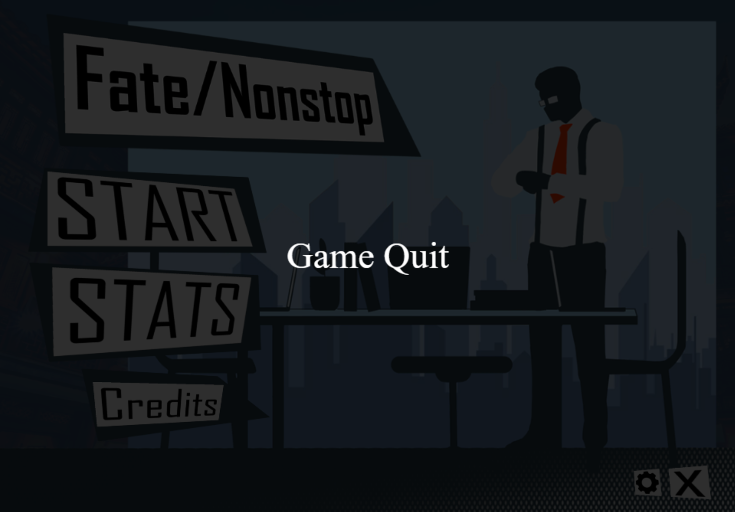

*Figure 10: Quitting the game*

The **Quit Game** button, that tints the entire screen, then show’s a text in the middle of the window saying that the game has been quit, and that it cannot be interacted with anymore.